Purpose: Problem Statements

- Identification of Coupled Nonlinear Modes From Free Vibration Using EMD+HHT Method (Conservative Nonlinear System)

Over the years, many investigations have focussed on the nonlinear extension of the definition of the normal mode defined in the classical theory of vibration. In this context, a nonlinear normal mode (NNM) of a conservative nonlinear system has been defined as a periodic oscillation where all the material points in the system reach their extreme value or pass through zeros simultaneously. The concept of NNM had been introduced by Rosenberg (1962), and another interesting concept in term of invariant manifolds was proposed by Shaw and Pierre (1993,1994). A more detail discussion and applications of NNM concept can be found in Vakakis (1997).
As in the case of linear theory, the NNM are associated with a particular set of initial conditions, and since the superimposition principle is not valid in the nonlinear case, the NNM can not be used directly to the response under arbitrary initial conditions. To overcome this difficulty, several approaches have been proposed. Szemplinska-Stupnicka (1990) introduced the concept of coupled nonlinear modes (CNMs). The free vibration oscillations (with arbitrary initial conditions) of a conservative nonlinear system are approximated by linear combination of harmonic terms. Each harmonic term depends on a mode shape vector and its corresponding frequency. Each couple of a frequency and mode shape vector defines a CNM, which depend on the amplitude of all CNMs. But each NNM depends only on its amplitude.
Since the CNMs provide a valuable tool for characterizing a mechanical system with nonlinear restoring forces, it is very important to identify the CNMs from the measured data. A method for identifying the CNMs based on Gabor transform has been proposed by Bellizzi, et al (2001). In this project, an advanced time-frequency decomposition method (EMD+HHT) will be applied to identify accurately the CNMs of conservative nonlinear system.
Consider an N-dof civil structural system governed by the following equation,
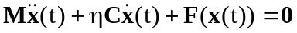 (1)
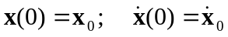 (2)
where is a damping constant and 0<<<1 (a lightly damped system); M and C are the mass and damping matrices (symmetric, positive-defined), respectively; F is a nonlinear restoring force, a monotonic piecewise continuously differentiable vector function.

1). Coupled Nonlinear Modes
In order to include the notion coupled nonlinear modes (CNMs), we consider the following autonomous conservative system associated with Eq.(1),
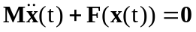 (3)
The coupled nonlinear modes are defined from a multi-harmonic approximation based on the harmonic balance method to the solution of Eqs. (2) and (3),
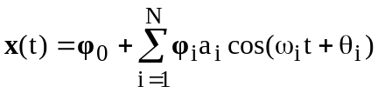 (4)
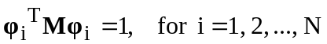 (5)
where the vector 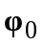 defines the position or offset, around which the movement is established, the frequency 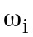 and mode shape 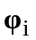 denote N nonlinear modes, and 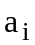> 0 and 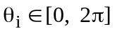 are constants depending on the initial condition 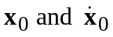. Due to the normalization property in Eq.(5), defines the modal amplitude of the ith coupled nonlinear mode.
Substituting Eq. (4) into Eq.(3), and applying the harmonic balance procedure yields the nonlinear algebraic equations,
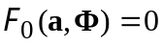 (6)
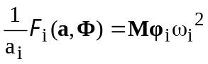, for i = 1, 2, …, N (7)
(8)
where
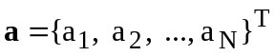, 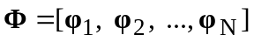 (9)
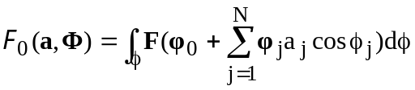 (10)
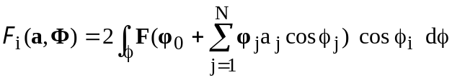 (11)
and 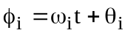 (12)
with the notation
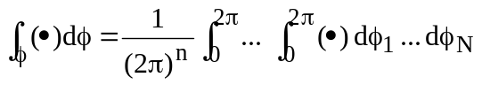 (13)
Solving, for fixed 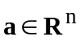, the nonlinear Eqs. (6)-(8), with respect to N²+2N unknowns , and yields the coupled nonlinear modes as a function of the amplitude vector a:
, for i = 1, 2, …, N (14)
The functions and characterizes the evolution of the frequency and the mode shape versus the amplitude vector a, respectively. A discussion about its existence and uniqueness can be found in [Bellizzi and Bouc (1999a)].

2). Free vibration response for the damped system in Eqs. (1) and (2)
Consider the amplitude-phase transformation
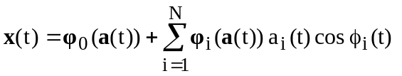 (15)
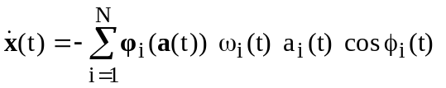 (16)
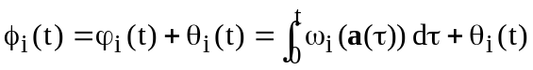, for i = 1, 2, …, N (17)
where , and denote the CNM, (t) > 0 and 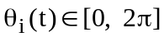 define the modal amplitude and the associated phase of the ith CNM, respectively. It is noted that due to the dissipative term in Eq.(1), the amplitude (t) and phase 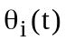 are now taken to be functions of time t, and 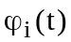 terms have been formulated in order to take into account the change in the instantaneous frequencies.
Based on Eqs. (15) – (17), the free vibration of the damped system in Eqs. (1) and (2) can be given by (in the averaging approximation sense),
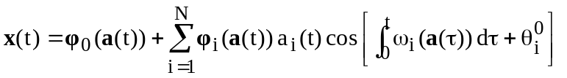 (15)
Also, due to a small , the amplitude (t) and phase are slowly varying functions with respect to the variation if x, so they can be solved approximately by the following equations,
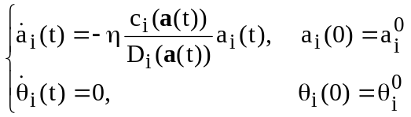; for I = 1, 2, …, N (16)
where the initial conditions 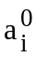 and 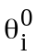 are constants depending on ,
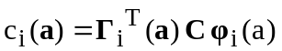 and 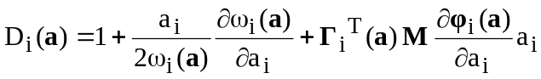 (17)
with 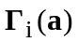 is the ith column vector of the adjoint modal matrix denoted 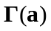, and the modal matrix 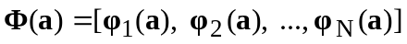.

3). Identification of CNMs Using EMD+HHT Method

Eq.(15) can be rewritten as
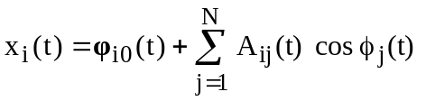, i = 1,2, …, N (18)
where
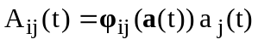 and 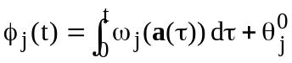 (19)
with 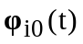 and 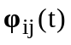 is the ith element of vectors 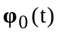 and 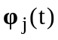, respectively.
Each 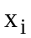(t) consists of a sum a quasi-harmonic terms with amplitudes, 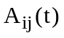, and instantaneous frequencies, 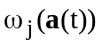, varying slowly with respect to time. The term 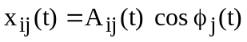 corresponds to the contribution of the jth CNM to (t).
From a time history of the transient response (t), i =1, 2, …, N, the proposed EMD+HHT procedure to identify the CNMs comprises the following steps.
(1). The function can be estimated by performance a simple low-pass filtering procedure that removes all the other CNMs.
(2). Through EMD method, the measured response (t) can be decomposed into N IMFs, 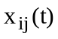, j = 1, 2, …, N.
(3). Applying HT to each IMF , the amplitude , the instantaneous frequency and phase 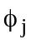(t) of each IMF are determined conveniently.
(4). From Eq.(19), the modal amplitudes 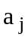(t) and the mode shapes 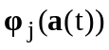 are determined by using the following formula;
For j = 1, 2, …, N,
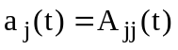
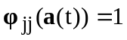
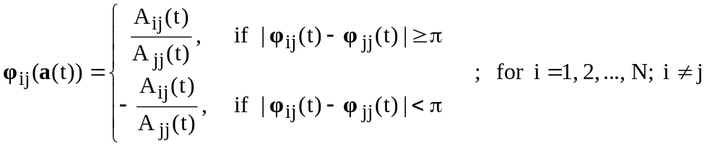

- Parametric Identification of Linear Structural Systems Based on Extended Kalman Filter or H∞ Filter Plus Hilbert Transform

The extended Kalman filter (EKF) [Jazwinski (1970)] was applied to system identification problems in seismic structural context. Recognition of the usefulness of the Kalman filter, which is essentially a method of sequential least squares estimation, leads to many application in structural identification. However, there are still some limitations on the stability and convergence of estimated parameters to exact ones, and on the sensitivity of initial conditions to the convergence in the application of the extended Kalman filter. In order to overcome these limitations, several approaches have been proposed. A weighted global iteration procedure (EK-WGI) was developed and applied to the extended Kalman filter algorithm [Hoshiya and Saito (1984)]. Another multi-step identification approach is proposed [Loh et al (1993, 1995)], where the system is first assumed to be adequately described by a linear system. If the linear system is able to accurately represent the response, then a nonlinear analysis is not needed; however, if the linear response does not adequately represent the structural response, the nonlinear analysis is called upon determine the location and degree of nonlinear behavior. Also, the convergence of EKF has shown to be a function of the number of parameters to be estimated [Straser and Kiremidjian (1996)]. Therefore, in this research, Hilbert Transform (HT) will be included into the extended Kalman Filter (EKF) or H∞ filter [Sato and Qi (1998)] algorithms, in order to improve the stability and convergence of estimated solution.
Consider an N-dof nonlinear structural system as follows,
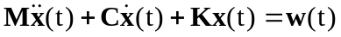 (1a)
where M, C, and K are mass, damping and stiffness matrices, respectively; and w = system’s external excitation.
Applying Hilbert transform to Eq.(1), we can obtain
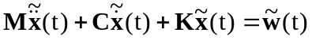 (1b)
where , and are the Hilbert transform of , and x, respectively.
Based on Eqs.(1), nonlinear state equation can be expressed as,
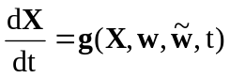 (2)
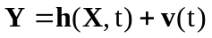 (3)
where the state variable 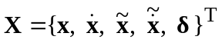, and are the Hilbert transforms of x and , respectively, and is the parameter vector to estimated; 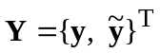, and is the Hilbert transform of the measurement vector y(t); v is the measurement white noise Gaussian processes with 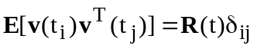, 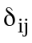 = the Kronecher delta.

1). Extended Kalman Filter Approach [Hoshiya and Saito (1984)]:
If the initial state vector estimate, 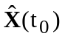 and the error covariance matrix , are given, and then as the observation data 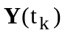, are processed, it is possible to estimate the state vector 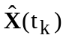 and the error covariance 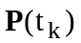, from Eqs. (4)-(8) as given in the following:

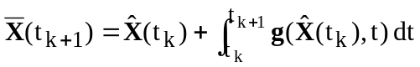 (4)
(5)
(6)
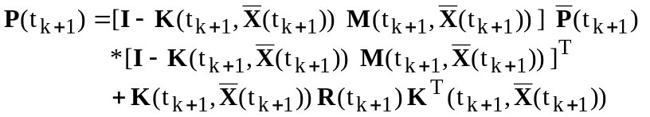 (7)
(8)
in which 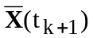 and 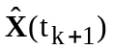 are the pre-estimator and post-estimator of state variable vector, respectively; 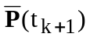 and 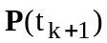 are the covariance matrices of and , respectively; 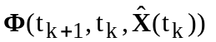= state transfer matrix from 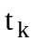 to 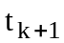; 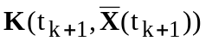= Kalman gain matrix at ; 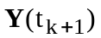 includes the measurement y and its Hilbert transform at ; and
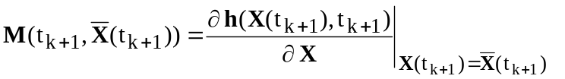
and the matrix  is given from Taylor’s expansion of first order as follows:
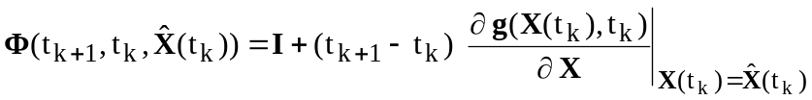 (9)
Thus the EKF algorithm in Eqs.(4)-(8) can be used for parametric identification of nonlinear structural systems. An objective function also can be included, and the EKF procedure for identification is shown in Fig.1.

2). H∞ Filter Approach [Sato and Qi (1998)]
The system equation in Eqs.(2)-(3) can be linearized and discretized using a proper linearization and discretion scheme such as [Sato and Takei (1997)]
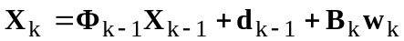 (10)
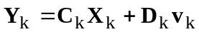 (11)
The system transfer matrix in this equation is given by
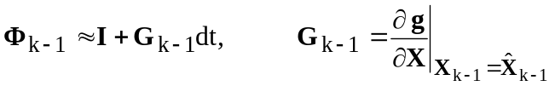 (12)
where dt = discrete time interval, and 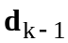 = constant term developed by linearization as
(13)
Moreover, assume that 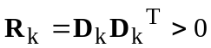 hold for any discrete time k.
The finite-horizon H∞ filtering problem [Takaba and Katayama (1996)] is to find estimates of 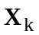 based on the measurement 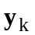, such that
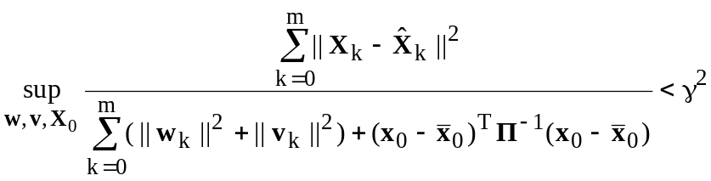 (14)
where 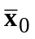= a priori estimate of the initial state, 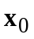,  = positive weighting matrix that represents the uncertainty of the initial state, and = positive constant that represents the magnitude of the penalty. The central H∞ filter that satisfies the prior H∞ bound is given in the following
(15)
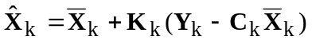 (16)
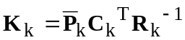 (17)
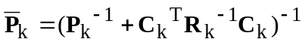 (18)
where 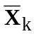 and 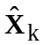 are the pre-estimate and estimate of the state variable vector at time , 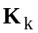= gain of the H∞ filter at time ; The covariance matrix 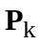 satisfies the Riccati difference equation
(19)
and
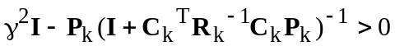 (20)
If tend to infinity, Eq. (19) is exactly the Riccati difference equation of the Kalman filter. Therefore, the H∞ filter is a modified version of the Kalman filter.
An objective function also can be included, and the H∞ filter procedure for structural identification is shown in Fig.1.

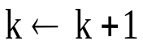
START
Given:
and
Using EKF or H∞ Filter Algorithm to find:
and
?
or objective function
?
Stop
No
Yes
Fig.1: Extended Kalman Filter or H∞ Filter Identification Approach
k = 0
3). Adaptive EKF or H∞ Filter Approach
Actually, another defect of the EKF or H∞ filter is that the post estimator of the state variable at the present time is a conditional estimator that puts equal weight on all past observation data. The EKF or H∞ filter can not track the non-stationary variation of the state variable. Therefore, a forgetting factor is included into these two algorithms so that these two filters can become more adaptive to the non-stationary identification, especially for the time-varying properties of structural systems. More detail discussion can be referred in [Sato and Takei (1998)] and [Sato and Qi (1998)].

- On-Line Identification of Hysteretic Systems

One of the challenges in actively controlling the nonlinear dynamic response of structural systems undergoing hysteretic deformations is the need for rapid identification of parameters for the nonlinear restoring force so that the information can be utilized by online control algorithms for determining the proper actuator forces needed to ensure stable response control of the oscillation flexible structure. The gradient projection algorithm, a standard technique found in the adaptive estimation and adaptive control literature, was used to obtain on-line estimates of the parameters of nonlinear hysteretic structural elements [Chassiakos et al (1998)]. The basic idea can be described as follows,
1). The time histories of the structural response [say, acceleration (t)], excitation, and hysteretic restoring force can be available for online measurement or computation;
2). The Bouc-Wen model is chosen as the identification model for its ability to capture the properties of a wide class of real nonlinear hysteretic systems;
3). Use a linearly parameterized estimator for the online estimation of hysteretic behavior;
4). A gradient projection adaptation law is used to estimate the unknown parameters so that the estimated restoring force can track the actual restoring force;
5). In this algorithm, the convergence to a unique parameter vector can not be guaranteed. However, the tracking of the output signal (restoring force) is performed well even with an overparametrized model.
For the gradient project adaptive law, the learning rate value, which drives the estimated parameter vector to the exact parameter vector, is constant. Also an excessively large gain value (or learning rate of the algorithm) could cause the estimation algorithm to be unstable. Therefore, another adaptive algorithm, i.e., least-squares-based adaptive law, which has a time-varying learning rate, is modified to a modified least-squares-based adaptive law with forgetting factor [Smyth et al (1999)]. The performance of the parameter estimation scheme is less dependent on the user’s initial choice of a suitable learning rate value. Also this algorithm has been applied to SDOF and MDOF systems.

